**МИНИСТЕРСТВО НАУКИ И ВЫСШЕГО ОБРАЗОВАНИЯ РОССИИ**

**ФГБОУ ВПО "Пензенский государственный университет"**

**Кафедра "Математическое обеспечение и применение ЭВМ"**

Отчет

по лабораторной работе №4

**«Формирование хранимых процедур в базе данных»**

Выполнили:

Хамзин Х.

Суворов М.

Хусаинов И.

ст. гр. 17ВИ1

Проверил:

доцент Казакова И.А.

**2020**

**Лабораторная работа №4**

Диаграмма базы данных гостиничного комплекса

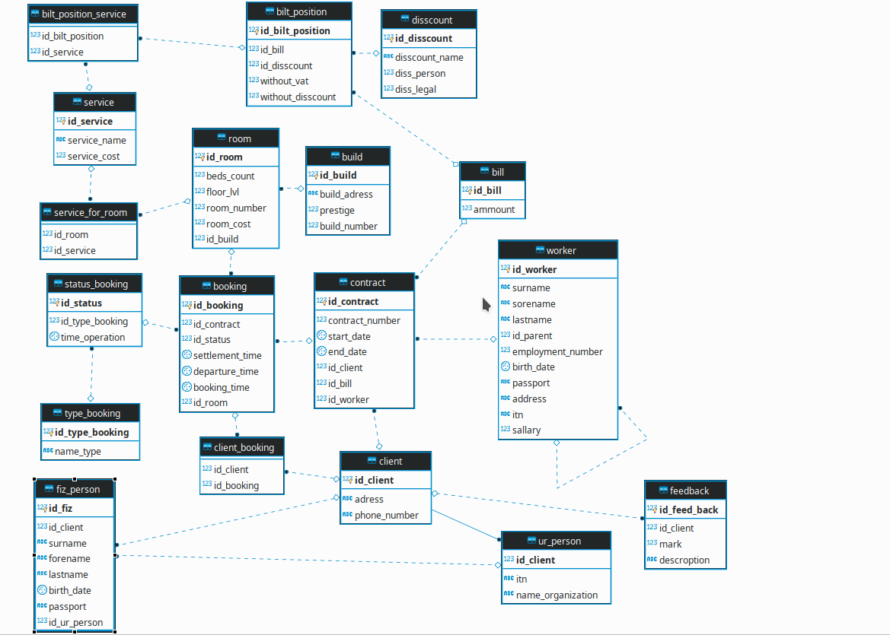

1. Предоставление итоговой суммы постояльцу:

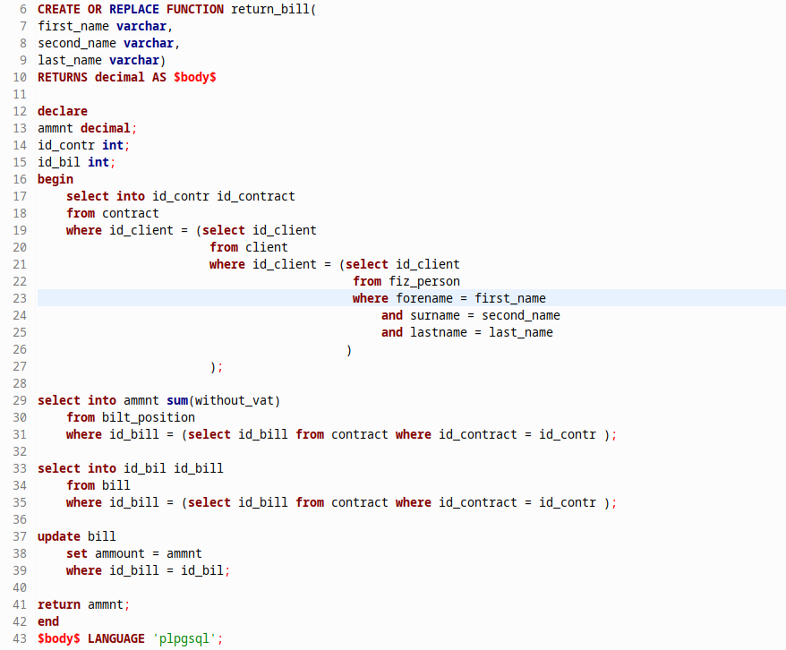

Вызов функции и результат выполнения:



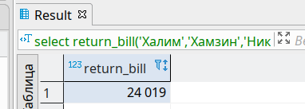

Проверка наличия записи в таблице bill

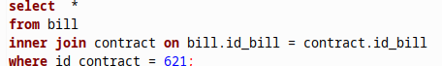

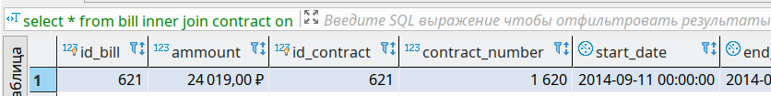

2.Заключение договора с юр. лицом

create or replace function create_contract_with_ur(

adrss varchar,

phone varchar,

itn_num varchar,

name_org varchar,

start_dt timestamp,

end_dt timestamp,

num_contract int,

worker_id int

)

RETURNS integer AS $body$

declare

bill_id int;

client_id int;

contract_id int;

begin

insert into client(adress,phone_number)

values (adrss, phone) returning client.id_client into client_id;

if(client_id is NULL) then

rollback;

return 0;

end if;

insert into ur_person(id_client, itn, name_organization)

values (client_id,itn_num, name_org);

insert into bill(ammount) values(0) returning bill.id_bill into bill_id;

if(bill_id is NULL) then

rollback;

return 0;

end if;

insert into contract(contract_number,start_date,end_date,id_client, id_bill,id_worker)

values(num_contract,start_dt,end_dt,client_id,bill_id,worker_id)

returning id_contract into contract_id;

if(contract_id is NULL) then

rollback;

return 0;

end if;

return contract_id;

end

$body$ LANGUAGE 'plpgsql';

Вызов функции и результат выполнения:

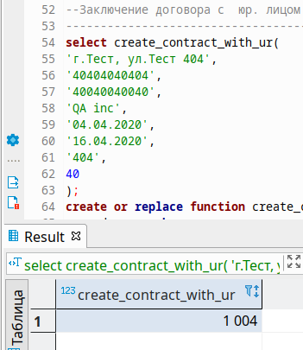

Проверка наличия записи в базе данных:

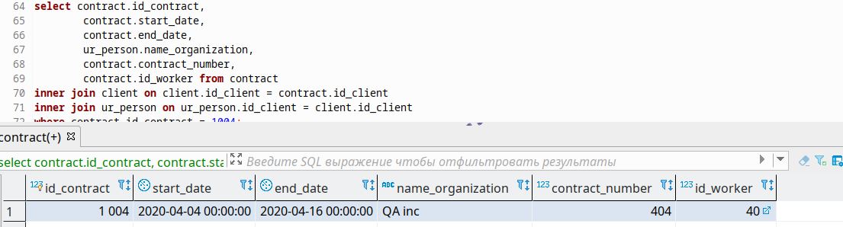

3.Функция проверки занятости номера в определенный промежуток времени

create or replace function is_avaibale_room(

start_date timestamp,

end_date timestamp,

room_num integer

)

returns integer as $body$

declare

is_avaibale integer;

begin

is_avaibale = 0;

SELECT into is_avaibale Count(Room.Room_number)

FROM Booking

JOIN Room ON Booking.id_room = Room.id_room

JOIN Build ON Build.id_Build = Room.id_Build

WHERE (Booking.Settlement_time BETWEEN start_date AND end_date

AND

Booking.Departure_time BETWEEN start_date AND end_date

AND Room.room_number = room_num)

OR (Booking.Settlement_time IS NULL AND

Booking.Departure_time IS NULL

AND Room.room_number = room_num);

if is_avaibale = 0 then

SELECT into is_avaibale Count(Room.Room_number)

FROM Room

JOIN Build ON Build.id_Build = Room.id_Build

LEFT JOIN Booking ON Booking.id_room = Room.id_room

WHERE Booking.id_booking is NULL AND Room.room_number = room_num;

if( is_avaibale = 0) then

raise log 'the room is unavailable';

return 0;

end if;

if(is_avaibale = 1) then

raise log 'the room is available';

return 1;

end if;

end if;

if(is_avaibale = 1) then

raise log 'the room is available';

return 1;

end if;

return 0;

end

$body$ LANGUAGE 'plpgsql';

Вызов функции и результат выполнения:

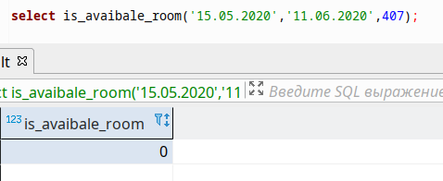

(Комната занята в этот период времени)

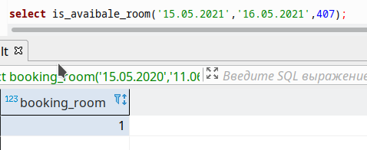

(Номер свободен)

4.Функция бронирования номера

CREATE OR REPLACE FUNCTION booking_room(

start_date timestamp,

end_date timestamp,

room_nb int,

id_contr int,

id_type_book int

)

RETURNS integer AS $body$

declare

now_time timestamp;

id_stts integer;

change_check integer;

check_room integer;

room_id int;

begin

select into room_id id_room from Room where room.room_number = room_nb;

now_time = NOW()::timestamp;

if(id_type_book = 1 or id_type_book = 3) then

select into change_check status_booking.id_status

from status_booking

inner join Booking on booking.id_status = status_booking.id_status

where Booking.id_contract = id_contr and Booking.id_room = room_id;

if(change_check is NULL) then

return 0;

end if;

update status_booking

set (id_type_booking,time_operation) = (id_type_book,now_time)

where id_status = change_check;

return 1;

end if;

check_room = is_avaibale_room(start_date, end_date, room_nb);

if(check_room = 1) then

if(id_type_book = 2) then

insert into status_booking(id_type_booking,time_operation)

values(id_type_book,now_time);

select into id_stts id_status

from status_booking

where id_type_booking = 2 and time_operation = now_time;

if(id_stts is NULL) then

return 0;

end if;

insert into booking(id_contract, id_status,settlement_time,

departure_time, booking_time, id_room)

values (id_contr, id_stts,start_date, end_date, now_time,room_id);

return 1;

end if;

end if;;

return 0;

end

$body$ LANGUAGE 'plpgsql';

Вызов функции и результат выполнения:

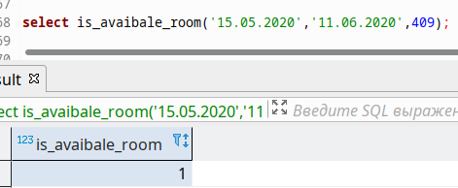

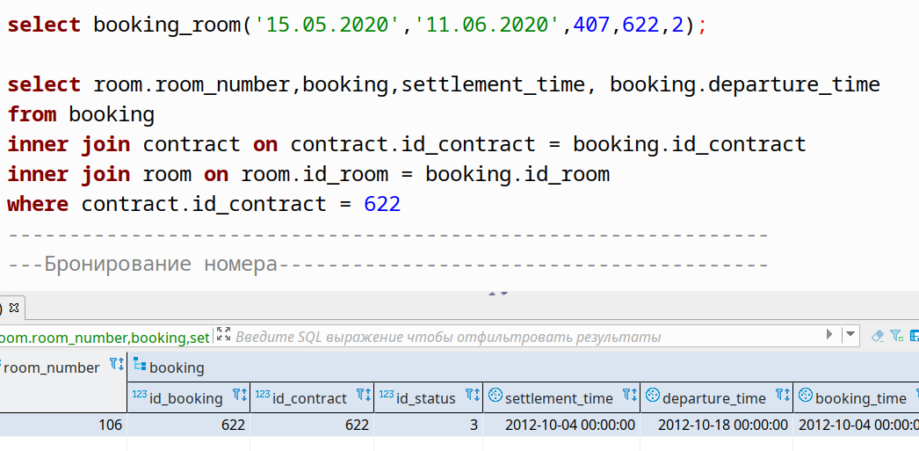

5.Вычисление суммы услуги или номера с учетом скидок

create or replace function update_cost_bilt_position(

id_room_input integer,

id_service_input integer,

id_discount_input integer,

is_fiz_person_input bool,

bilt_position_id integer

)

RETURNS integer AS $body$

declare

service_cost_find decimal;

room_cost decimal;

persent_discount_person decimal;

persent_discount_legal decimal;

target_discount decimal;

cost_with_discount decimal;

cost_with_out_nds decimal;

begin

if (id_room_input = 0 and id_service_input = 0) then

rollback;

return 0;

end if;

if (not exists( select * from disscount where id_disscount = id_discount_input))then

raise log 'there is no discount';

rollback;

return 0;

else

select into persent_discount_person disscount.diss_person from disscount

where id_disscount = id_discount_input;

if (is_fiz_person_input) then

target_discount = persent_discount_person;

else

select into target_discount disscount.diss_legal

from disscount

where id_disscount = id_discount_input;

end if;

end if;

if(id_room_input = 0) then

if( not exists(select * from service where service.id_service = id_service_input)) then

raise log 'there is no service';

rollback;

return 0;

end if;

select into service_cost_find service.service_cost from service

where service.id_service = id_service_input;

cost_with_discount := service_cost_find - (service_cost_find / 100) * target_discount;

cost_with_out_nds := service_cost_find - (service_cost_find /100) * 18;

update bilt_position set

without_vat=cost_with_out_nds,

without_disscount=service_cost_find,

with_discount=cost_with_discount

where bilt_position.id_bilt_position = bilt_position_id;

return 1;

else

if( not exists(select * from room where room.id_room = id_room_input)) then

raise log 'there is no rooms';

rollback;

return 0;

end if;

select room.room_cost into room_cost from room

where room.id_room = id_room_input;

cost_with_discount = room_cost - (room_cost / 100) * target_discount;

cost_with_out_nds = room_cost - (room_cost /100) * 18;

update bilt_position set

without_vat=cost_with_out_nds,

without_disscount=room_cost,

with_discount=cost_with_discount

where bilt_position.id_bilt_position = bilt_position_id;

return 1;

end if;

return 0;

end

$body$

LANGUAGE PLpgSQL;

Вызов функции и результат выполнения:

